Game Design Document

Fill up the Following document

1. Write the title of your project.

Meteorite bash

1. What is the goal of the game?

To destroy the meteorite with a slingshot

1. Write a brief story of your game?

The game is basically a stone which you have to hit with a slingshot. You have to hit the meteorites. If you miss the meteorite once you lose completely. But if you hit a meteorite 3 times in a row you win.

1. Which are the playing characters of this game?

* Playing characters are the ones which respond to the user based on the input from the user
* Cars, monkeys, dinos, wizards etc, are the playing characters in the game.

|  |  |  |
| --- | --- | --- |
| Number | Character Name | What can this character do? |
| 1 | Slingshot | Gives the meteorite a stretch to hit the meteorites |
| 2 | stone | Hits the meteorites with the help of the slingshot. |
| 3 |  |  |
| 4 |  |  |
| 5 |  |  |
| 6 |  |  |
| 7 |  |  |
| 8 |  |  |

1. Which are the Non Playing Characters of this game?

* Non Playing characters are the ones which don't have an action or a behaviour when the user interacts with the game.
* Hurdles, stones, bananas, coins, etc are non playing characters in the game.

|  |  |  |
| --- | --- | --- |
| Number | Character Name | What can this character do? |
| 1 | lifelines | Remove chances to play |
| 2 | meteorites | Comes in random positions for the stone to hit it |
| 3 |  |  |
| 4 |  |  |
| 5 |  |  |
| 6 |  |  |
| 7 |  |  |
| 8 |  |  |

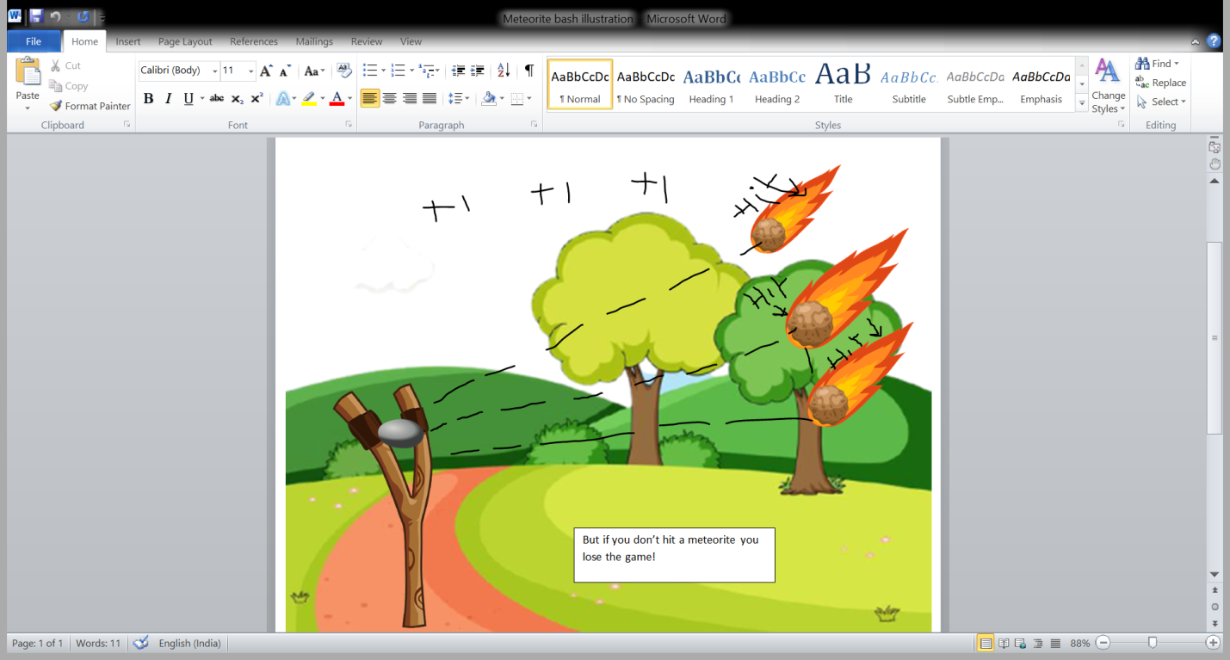Draw your imagination of this game. What does this game look like?

* Draw the game either on your computer or on paper,
* Add images of scenes of the game to show each of the playing and non-playing characters at least once.

How do you plan to make your game engaging?

So basically, when you miss the meteorite once you lose completely but if you win 3 times in a row you win the game. And the meteorite becomes smaller all 3 times.